2009 NATIONAL BANK SUMMER KICKOFF @ Virginia Tech
T-Shirt Order Form
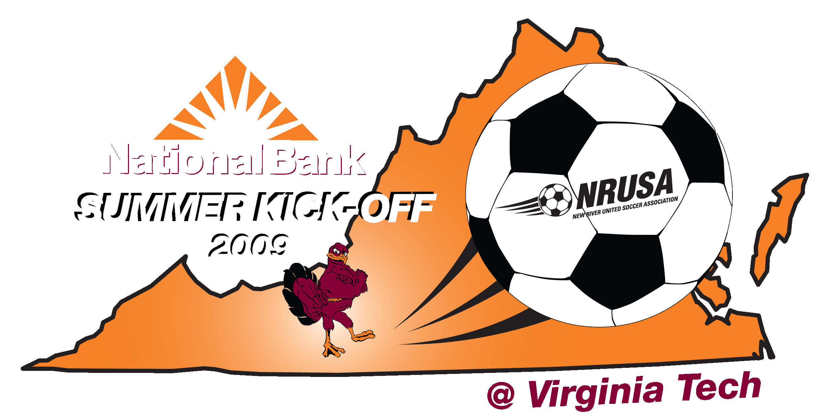
The tournament logo (Pictured) will be available on a white short-sleeve t-shirt from Hi Peak Sportswear.
The tournament logo will be on the front of the shirt and our tournament sponsors will be on the back of the shirt. Prices listed below are only for items pre-ordered by April 30th.
T-shirts will be available on a limited basis at registration and at the tournament sites @ $15.
phone: (540) 381-0066 email: tbrown@nrusa.org fax: (540) 518-9187
Team Name: __________________________________________ Age Group: U_____ Boys/Girls (Circle One)

Contact Person: _________________________________Email:_____________________________________

Phone Number: ________________________Cell:______________________Work:____________________

Address: _________________________________________________________________________________

City: _____________________________ State: __________________ Zip: ______________________
Size | # of Shirts | Price |  | Total Due
Youth Large |  | @$12
Adult Small |  | @$12
Adult Medium |  | @$12
Adult Large |  | @$12
Adult XL |  | @$12
Adult XXL |  | @$12
Total # Shirts |  |  | Total Due
Checks should be made payable to: NRUSA
Mailing Address:
Tournament T-Shirts, NRUSA
2890 N. Franklin Street, Suite D Christiansburg, VA 24073
The order is not complete until we receive your check

